Dotaz k 3e

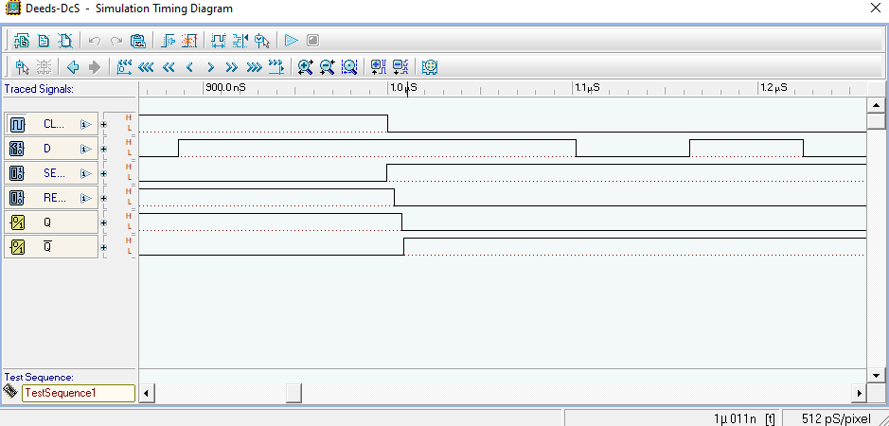
s = 1, r = 0, q = 1, cl = 0
s = 1, r = 0, q = 0, cl = 0

